**Deploy the Dashboard**

1. **SSH to the HAPROXY VM and run the below commands.**

|  |
| --- |
| # kubectl apply -f https://gist.githubusercontent.com/lc-kubeadm/5b8896b47ee046d33d73d51ef9dabc48/raw/d89fe9c5446dd9ee4b412d219c308bf2205003e0/kubernetes-dashboard.yaml |

2. You can grant full admin privileges to Dashboard's Service Account by creating below ClusterRoleBinding. Copy the YAML file and save as dashboard-admin.yaml. Use kubectl to deploy it. Afterwards you can use Skip option on login page to access Dashboard.

|  |
| --- |
| # vim dashboard-admin.yaml |

|  |
| --- |
| apiVersion: rbac.authorization.k8s.io/v1beta1 kind: ClusterRoleBinding metadata:  name: kubernetes-dashboard  labels:  k8s-app: kubernetes-dashboard roleRef:  apiGroup: rbac.authorization.k8s.io  kind: ClusterRole  name: cluster-admin subjects: - kind: ServiceAccount  name: kubernetes-dashboard  namespace: kube-system |

**Save and exit by the escape key and :wq ( hit enter to exit).**

**3. Apply the dashboard admin role that was created in step 2**

|  |
| --- |
| # kubectl apply -f dashboard-admin.yaml |

4. Edit the Kubernetes Dashboard Service to Expose it.

|  |
| --- |
| # kubectl edit svc kubernetes-dashboard -n kube-system |

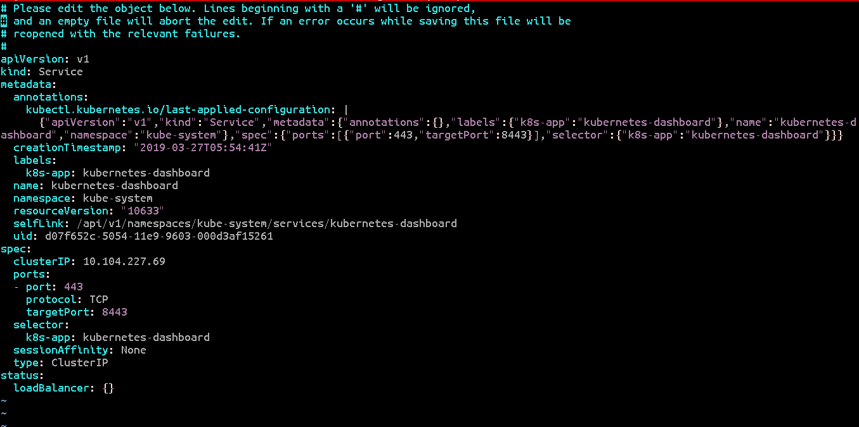

5. Update the type from **type: ClusterIP** to **type: NodePort**

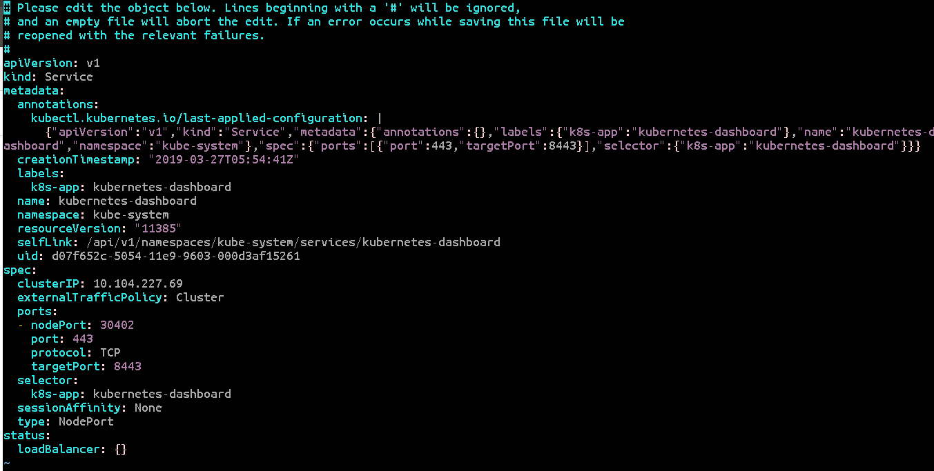

**Save and exit by pressing ecs key, wq! And press enter to exit.**

**7. Run the below command to check the deployment NODE of the K8sDashboard.**

|  |
| --- |
| **# kubectl get po -n kube-system -o wide** |

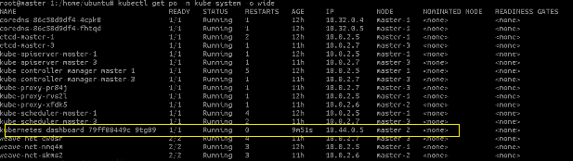

**In this example the kubernetes-dashboard-79ff88449c-mnvfr is running on master-3**

**8. Get the NODEPORT of the Dashboard**

|  |
| --- |
| **# kubectl get svc -n kube-system** |

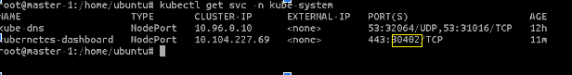

**In this example the kubernetes-dashboard is exposed on port 30402**

**Check the NODE where the Kubernetes Dashboard is running and the NodePort on which it is exposed.**

**Access the Dashboard**

Login to the Azure Portal to get the public IP of the NODE where the dashboard is deployed ( in this example master-3 vm).

From the Public-IP ( of the NODE where the Dashboard POD is deployed) and the port on which it is exposed.

**https://<NODE-VM-PUBLIC-Ip>:<PORT-NUMER>**

Example

[**https//104.211.186.228:32003/**](http://104.211.186.228:32003/)

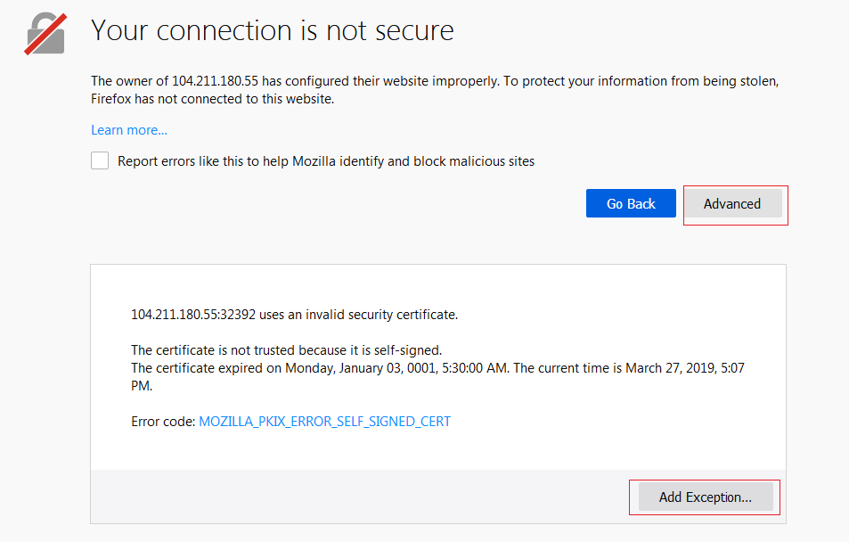

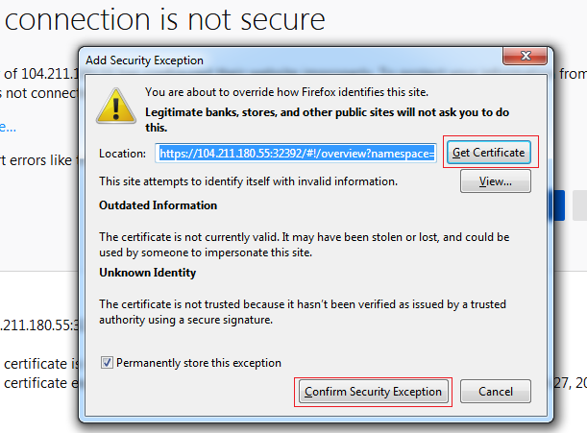

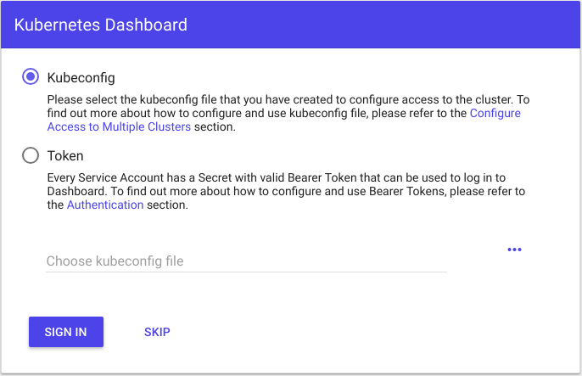

Click on the **SKIP** button

